GGR272 Assignment 4

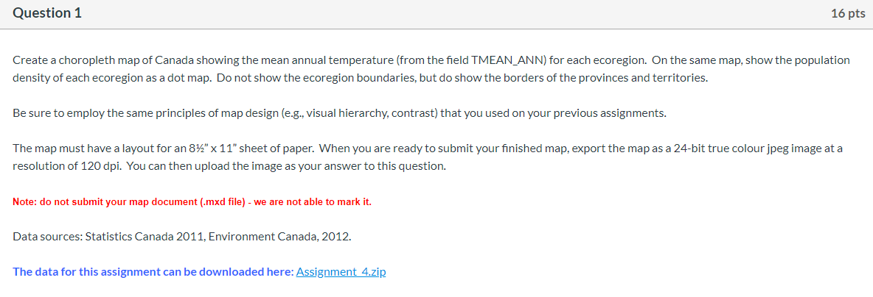

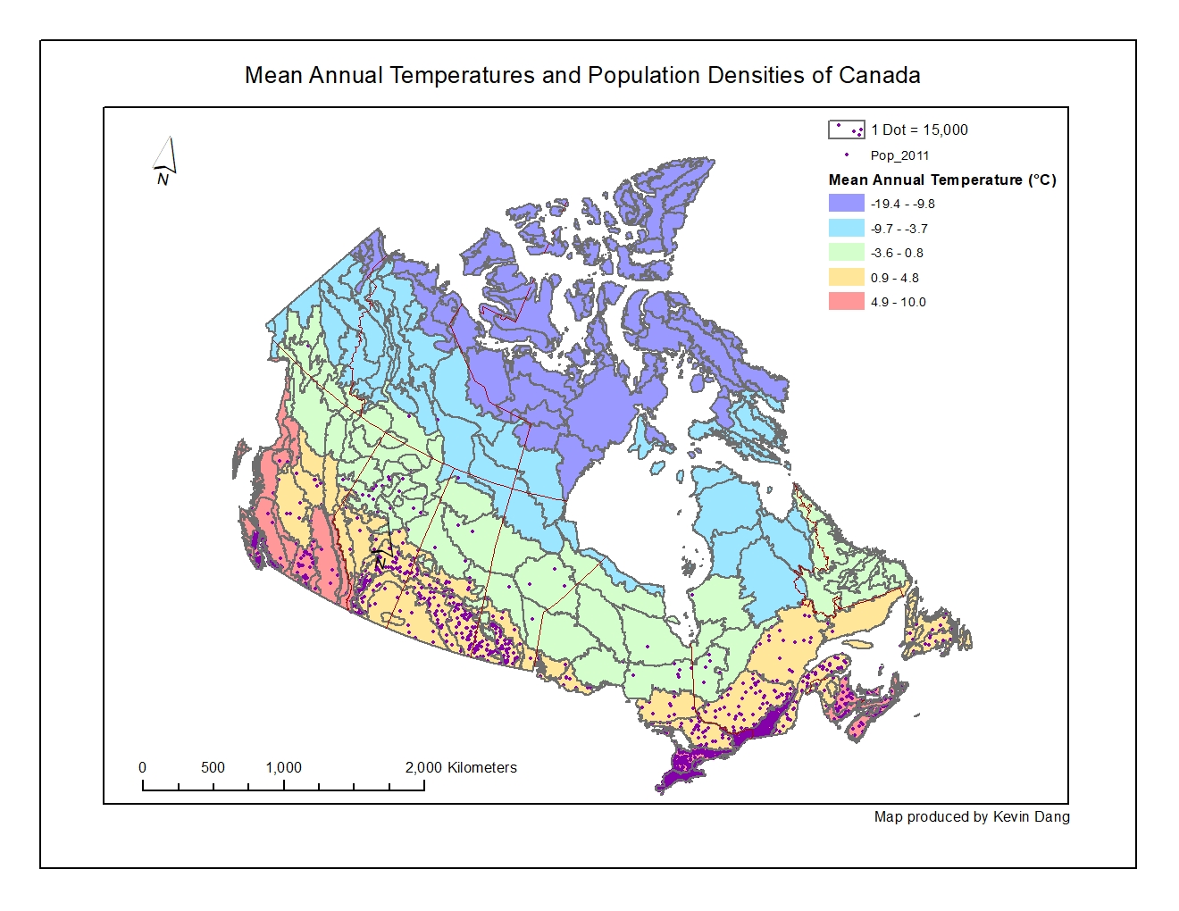



My classification method of choice is quantiles. I chose quantiles because it separates the data evenly into a set number of classes, and I also work with quantiles quite often as a statistics student. I went with five classes since I wanted an odd number to show a neutral zone in the center and I felt that going with seven would be too many colours for the viewer to distinguish, whereas three would not be enough. I opted for a rainbow colour scheme to show temperature from cold to hot ranging from blue to red, since is it easy for us to associate certain colours with temperature.

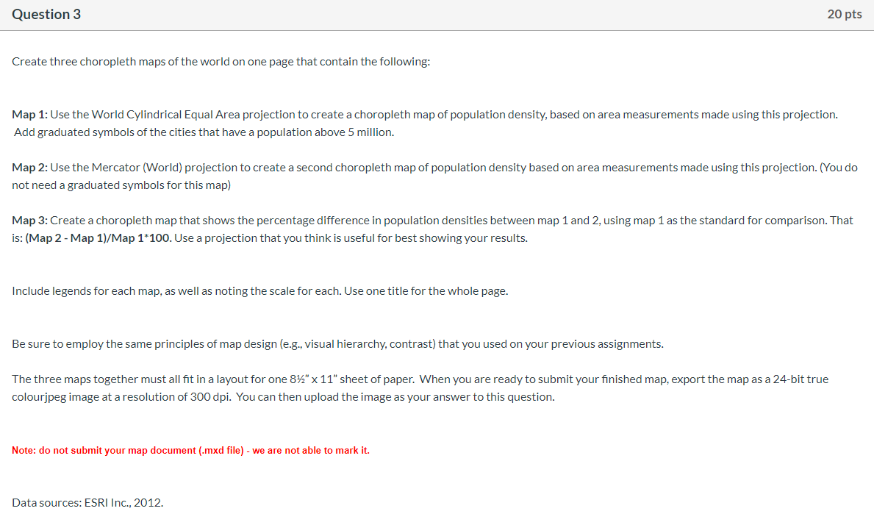

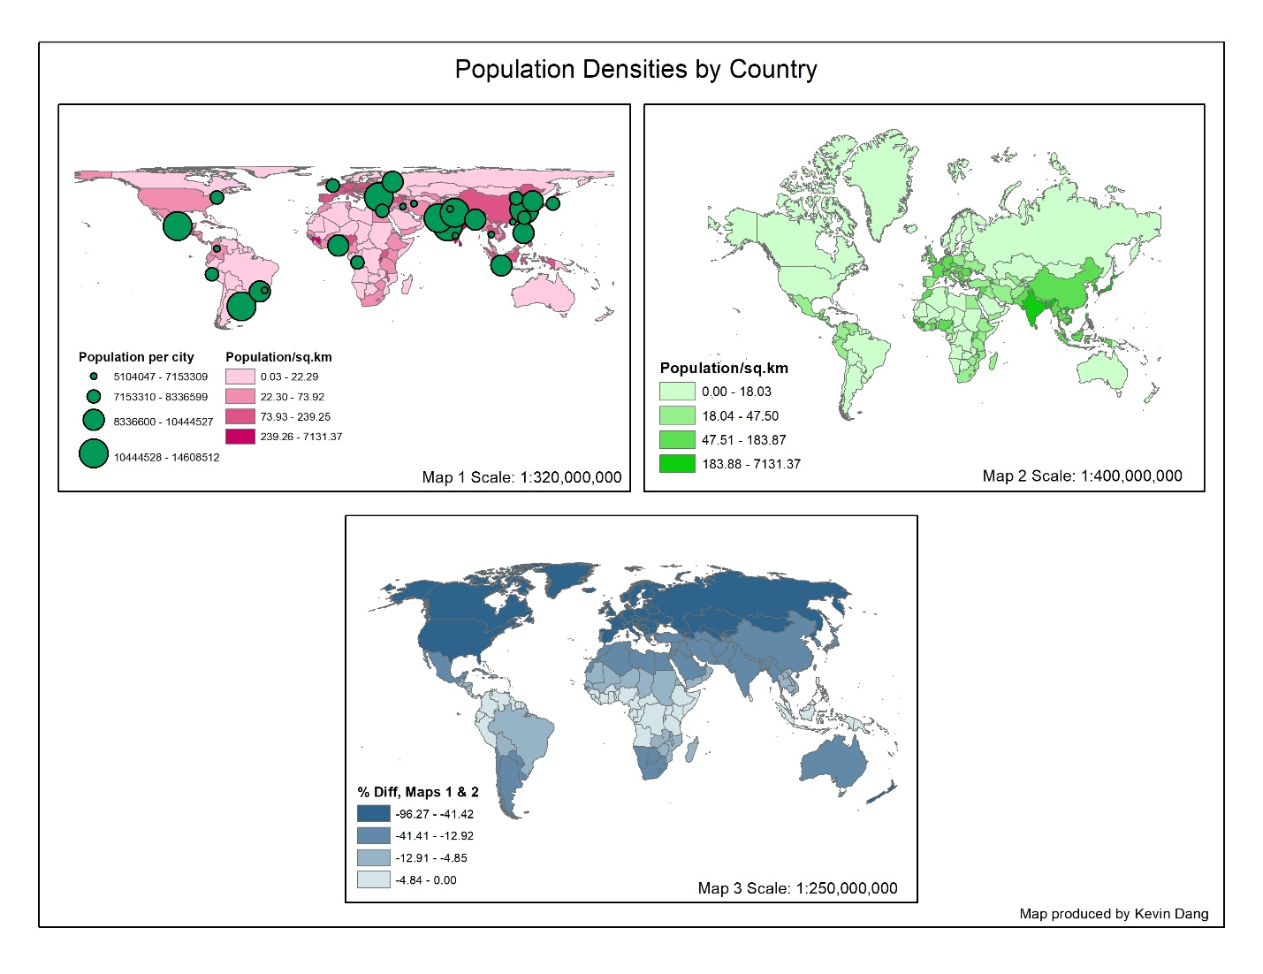

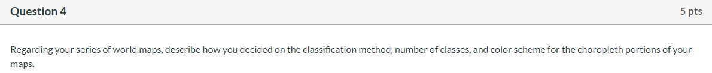

My classification method of choice is quantiles, the same method used as in question 1. I chose quantiles because it separates the data evenly into a set number of classes, and I also work with quantiles quite often as a statistics student. I went with four classes for all maps as that is a common choice for choropleth maps and I did not want too many as that would clutter the map, but at the same time it is enough classes to distinguish the various population densities. As for the colour scheme, I went with different shades of a single colour for each map. This makes sense as we are not measuring temperature but rather we are measuring population density, which starts off at a minimum of zero and goes up to the largest population density value.

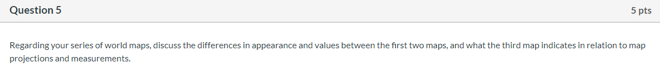

In Map 1, there is no distortion at the equator but there is shape distortion at the poles which makes the countries appear shorter and wider. The areas of the countries are maintained however the shapes are not. In Map 2, the shapes are maintained however the areas are much bigger towards the poles, and is only maintained for a select few countries near the equator. The third map shows the percentage difference in population densities between maps 1 and 2. We know that population density is given by population divided by area and from the projections we can see that Map 2 has areas **larger** than or equal to the area in Map 1. This means that the population density of Map 2 is **less** than or equal to the population density in Map 1, which is what we see in the legend in the form of negative percentage differences up to a maximum of zero percent after using Map 1 as the standard for comparison.